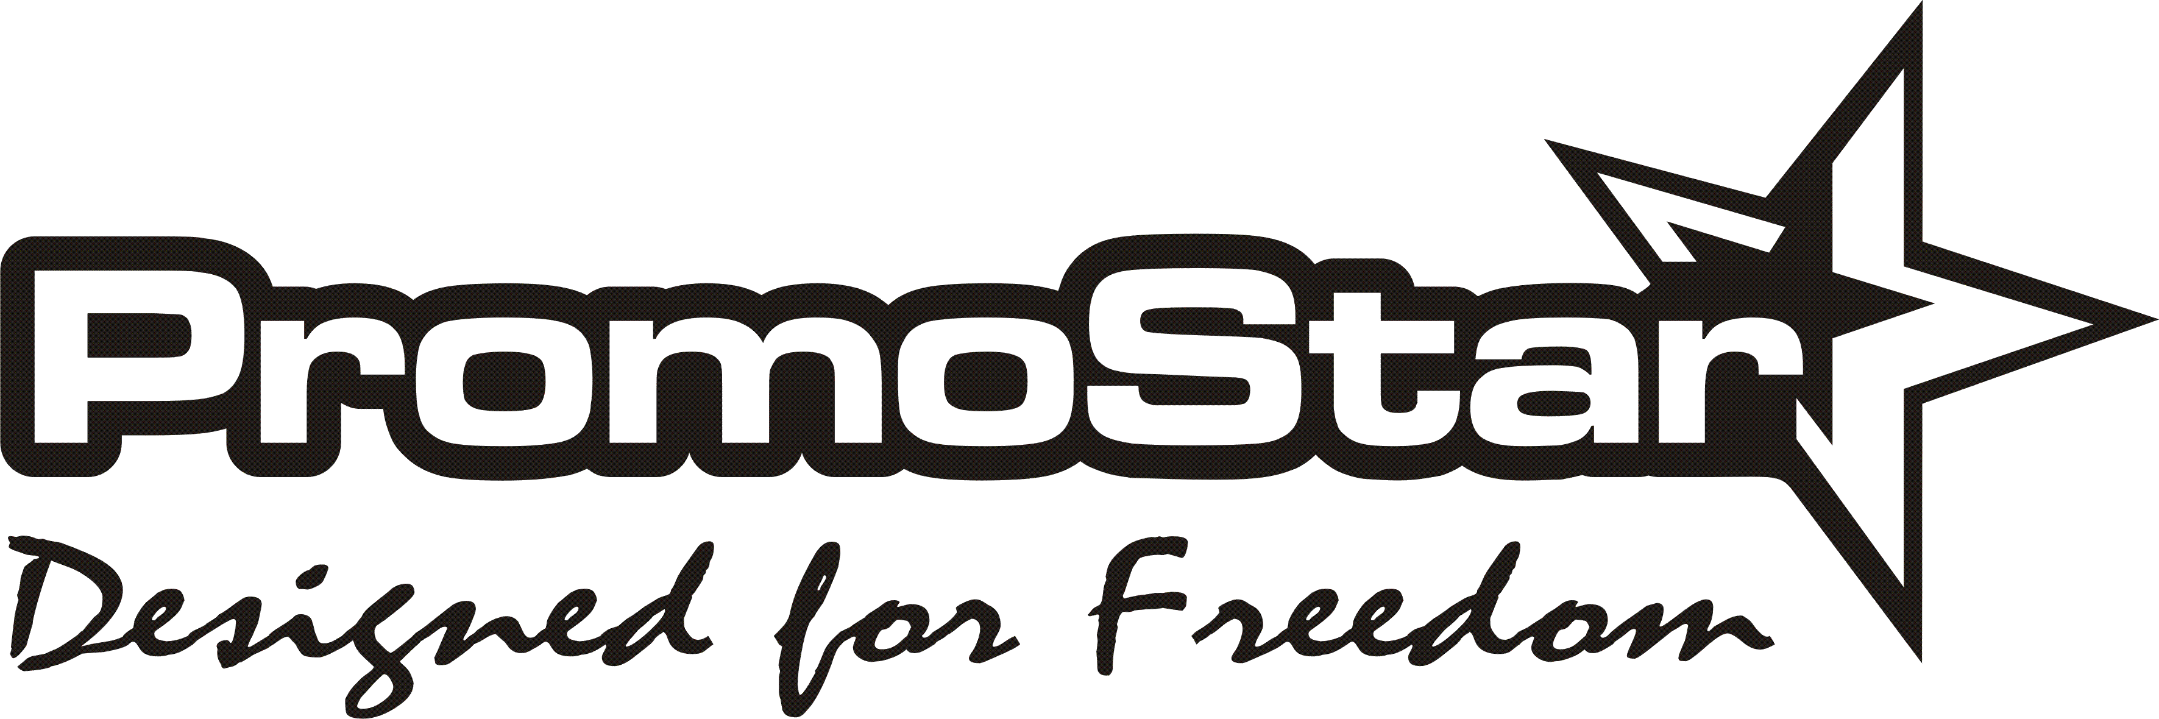

EQUIPMENT RENTAL AGREEMENT AND WAIVER

Full Name: ....................................................................Passport or ID #: .........................................................

Date and place of birth: ......................................................................................................................................

Physical address while stay in Zanzibar (Hotel name & room No.): ...............................................................

Phone: ..........................................................Emergency Contact: ....................................................................

I am renting the following equipment: (Please Check and/or Circle Appropriate Equipment)

Sit-on Top Kayak Single or Double incl. seat(s) and ......... x paddle(s) and ............ x Lifejacket(s)

I am responsible for the return of this equipment in the same state in which I received it. I agree to pay in full for any repairs or replacement if the equipment is damaged or lost, and/or a retrieval fee if Zanzibar Adventure Club has to retrieve any rented equipment. I further agree to make every reasonable effort to return all equipment to point-of-rent.
I AM AWARE THAT KAYAKING IS A DANGEROUS SPORT AND I AM AWARE OF THE DANGERS OF KAYAKING. I UNDERSTAND THAT Zanzibar Adventure Club IS IN NO WAY RESPONSIBLE FOR MY SAFETY OR THE SAFETY OF THE EQUIPMENT I AM RENTING.
I understand that I will need to complete and sign the Waiver and Release of Liability Form
prior to commencing my rental agreement with Zanzibar Adventure Club

___________________________
( Renter’s Signature )

Waiver and Release of Liability Form

1. Assumption of Risk:
I know and understand the scope, nature, and extent of the risks involved in activities contemplated by the agreement and voluntarily and freely chooses to incur such risks.
2. Exemption from Liability:
I agree to assume all risks in connection with the use of the equipment, whether foreseen or unforeseen and whether or not caused by the fault or negligence of Zanzibar Adventure Club and/or its employees. I also agree to release Zanzibar Adventure Club and/or its employees from all liability for any harm, injury or damage, which may befall myself or the equipment I rent. I also agree to indemnify and save and hold harmless Zanzibar Adventure Club and/or its employees from any claim by me, my family, estate, heirs, assigns or any third party arising out of my rental of the equipment.

I have had all medical examinations I believe are necessary to assure of and assume responsibility for my physical fitness and capability to use the equipment. I will keep my lifejacket on and buckled at all times while on the water. I agree to follow the advice and instructions of Zanzibar Adventure Club staff; always remain at a distance of at least 50 meters from commercial vessels and at a reasonable distance from recreational boats.
I agree to repair or replace in a manner acceptable to Zanzibar Adventure Club any of the equipment damaged while I am renting it. If I fail to repair or replace such equipment in an acceptable manner, I will pay Zanzibar Adventure Club the cost incurred in repairing or replacing the equipment as determined by Zanzibar Adventure Club.

I further state that I am of lawful age and legally competent to sign this agreement. I also understand that this is a contract and not a mere recital, and I agree I have signed this contract as my own free act.
I HAVE FULLY INFORMED MYSELF OF THE CONTENTS OF THIS AGREEMENT BY READING IT BEFORE I SIGNED.

_____________________________ _____________________________ ___________________
Renter’s Signature Printed Name Date

